Explanation of Python Code

# 1. Introduction

This Python program performs three separate tasks:  
1. Validates a credit card number using the Luhn algorithm.  
2. Removes punctuation from a given sentence.  
3. Sorts words alphabetically from a given line of text.

# 2. Luhn Check Function

The function `luhn_check(card_number)` checks whether a credit card number is valid according to the Luhn algorithm. The steps are:  
- Extract only digits from the input string.  
- Remove the last digit (the check digit).  
- Reverse the remaining digits.  
- Double every second digit (starting from index 0). If doubling results in a number greater than 9, subtract 9.  
- Sum all the digits along with the check digit.  
- If the total is divisible by 10, the card number is valid.

# 3. Card Number Input

The program asks the user to enter a card number. It passes this input to the Luhn check function. If the number is valid, it prints 'Valid'; otherwise, it prints 'Invalid'.

# 4. Removing Punctuation

The program then asks the user to enter a sentence. It defines a string of common punctuation characters. By using a generator expression, it removes all punctuation from the sentence and prints the cleaned text.

# 5. Sorting Words

The program asks the user to input a line of text. It splits the line into words, sorts them alphabetically (ignoring case), and prints the sorted result as a single string.

# Output SecreenShort

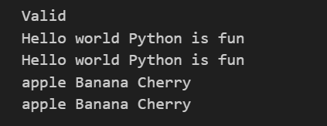

# 6. Summary

In summary, this program demonstrates string manipulation, sorting, and algorithmic validation. It combines three different functionalities:  
- Validating credit card numbers.  
- Cleaning text by removing punctuation.  
- Sorting words alphabetically.  
This helps users practice multiple Python concepts in a single program.